Calculating Family Expenses using Service Now

**Team Id:**

**NM2025TMID19987**

**Team Leader:**

**Sandhiya. R**

**Team Members:**

1. **Subhalakshmi. V**
2. **Nadhiya. B**
3. **Janani. C**
4. **Mahalakshmi. S**

**Problem Statement:**

The project aims to develop a comprehensive expense calculation system using ServiceNow. This system will enable users to track and manage family expenses efficiently. It will include features such as expense categorization, budget setting, real-time tracking, and reporting capabilities. Utilizing ServiceNow's robust platform, the project will ensure seamless integration, user-friendly interface, and scalability to accommodate varying family sizes and financial complexities. The end goal is to empower users with the tools they need to make informed financial decisions and promote financial well-being within the family unit.

# TASK INITIATION

**Milestone 1: Setting up ServiceNow Instance Activity 1: Setting up ServiceNow Instance**

1. Sign up for a developer account on the ServiceNow Developer site

“https://developer.servicenow.com”.

1. Once logged in, navigate to the "Personal Developer Instance" section.
2. Click on "Request Instance" to create a new ServiceNow instance.
3. Fill out the required information and submit the request.
4. You'll receive an email with the instance details once it's ready.
5. Log in to your ServiceNow instance using the provided credentials.
6. Now you will navigate to the ServiceNow.

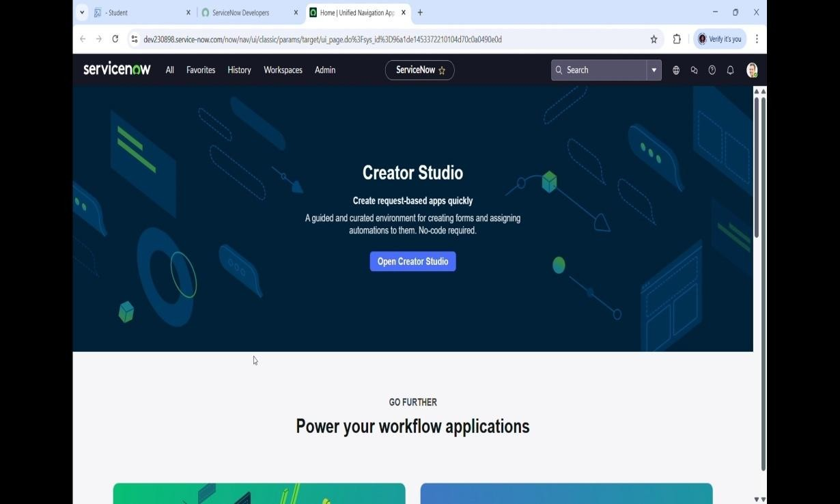

# Milestone 2 : Activity 1: Creation of New Update Set

* 1. Go to All >> In the filter search for Local Update set > click on New.
  2. Enter the Details as: Name : Family Expenses
  3. Then click on Submit and Make current.

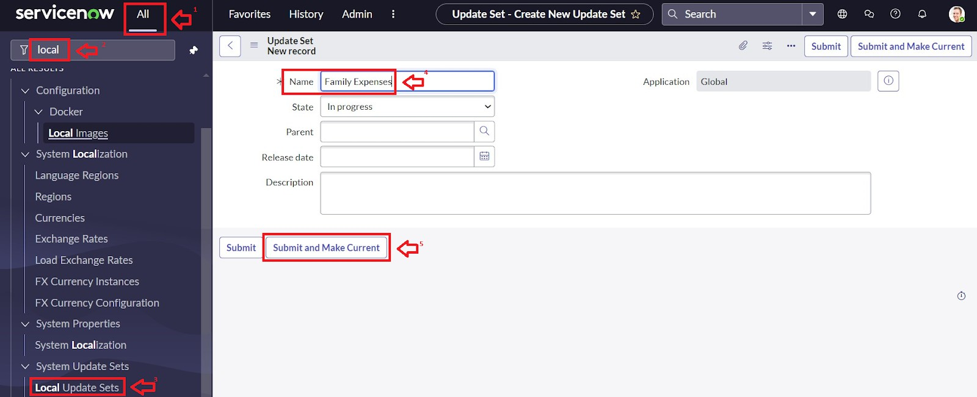

# Milestone 3: Activity 1: Creation of New Update Set

1. Go to All >> In the filter search for Local Update set > click on New.
2. Enter the Details as: Name: Family Expenses
3. Then click on Submit and Make current.

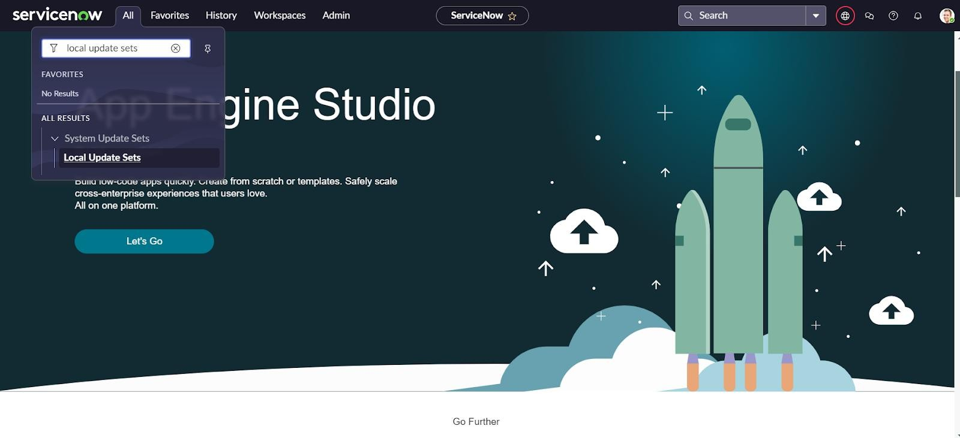

# Milestone 4: Activity 1: Creation of Family Expenses Table

1. Go to All > In the filter search for Tables > click on New.
2. Enter the Details: Label: Family Expenses Name: Auto-Populated

New menu name: Family Expenditure

1. Go to the Header and right click there>> click on Save.

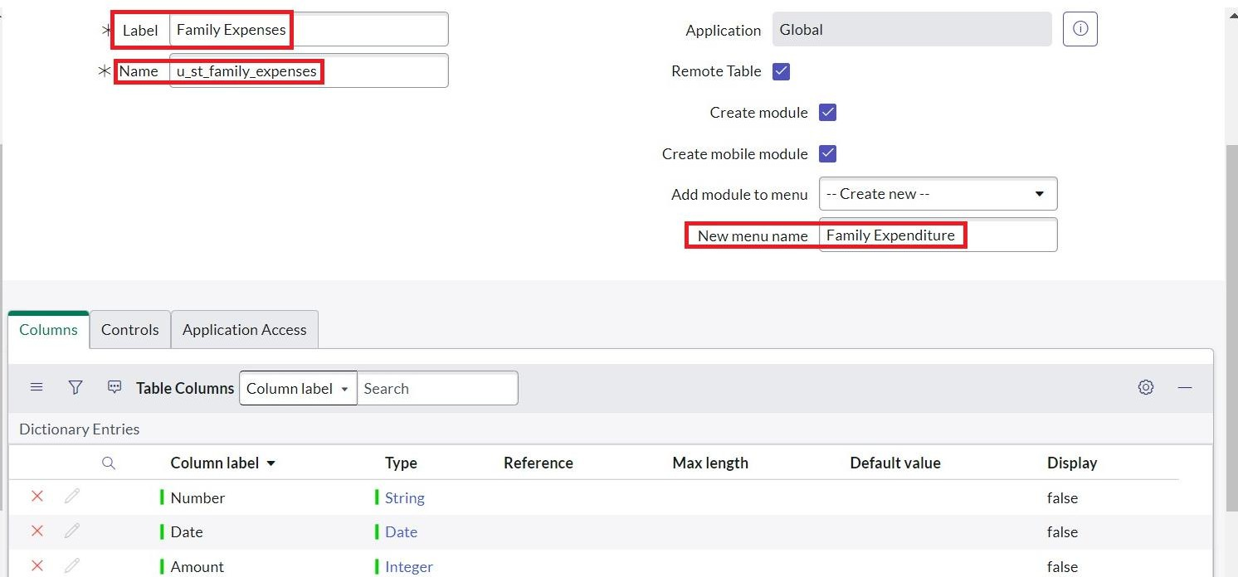

# Activity 2: Creation of Columns (Fields)

1. Near Columns Double click near insert a new row.
2. Give the details as: Column label: Number Type: String
3. Double click on insert a new row again
4. Give the details as: Column label: Date Type: Date
5. Double click on insert a new row again
6. Give the details as: Column label: Amount Type: Integer

Double click on insert a new row again

1. Give the details as:

Column label: Expense Details Type: String

Max length: 800

9. Go to the Header and right click there>> click on Save.

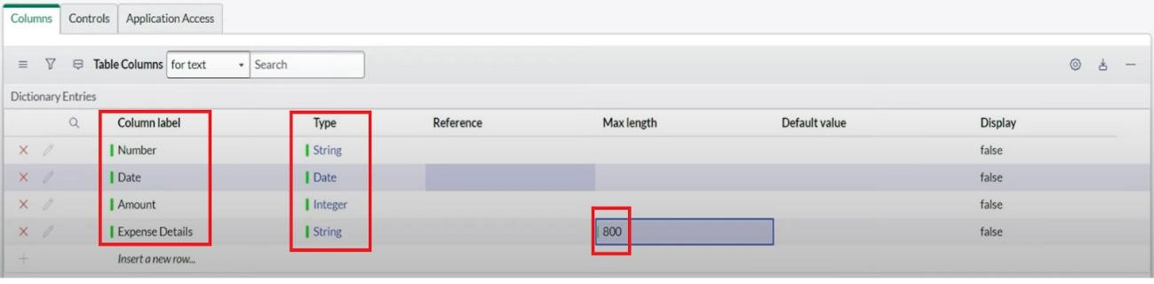

# Activity 3: Making Number Field an Auto-Number

1. Double click on the Number Field/Column.
2. Go down and double click on Advanced view
3. In Default Value:

Use dynamic default: check the box

Dynamic default value: Get Next Padded Number

1. Click on Update.
2. Go to All >> In the filter search for Number Maintenance >> select Number Maintenance
3. Click on New.
4. Enter the below Details: Table: Family Expenses Prefix: MFE
5. Click on Submit.

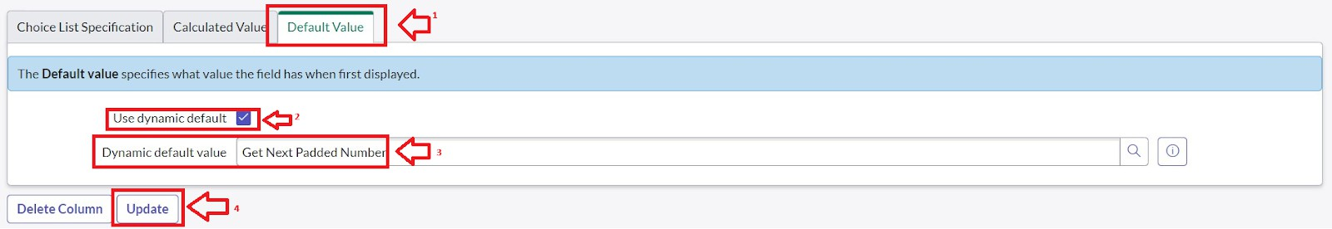

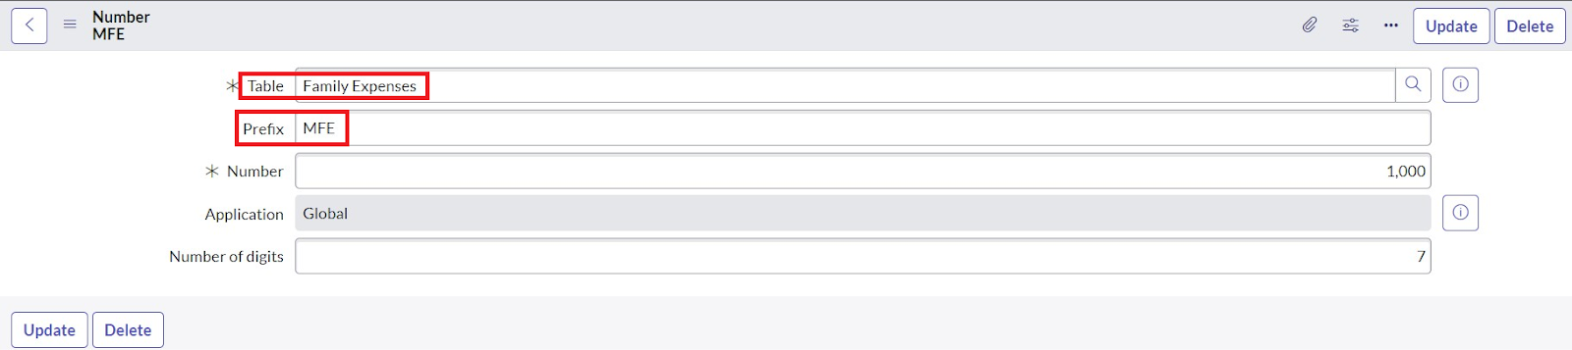

# Activity 4: Configure the Form

1. Go to All >> In the filter search for Family Expenses >> Open Family Expenses
2. Click on New
3. Go to the Header and right click there>> click on Configure >> Select Form Design
4. Customize or Drag Drop the form as per your requirement.
5. Make Number Read-Only Field by clicking on the gear icon and checking Read-Only
6. Make Date, Amount Mandatory Field by clicking on the gear icon and checking Mandatory.
7. Click on Save.

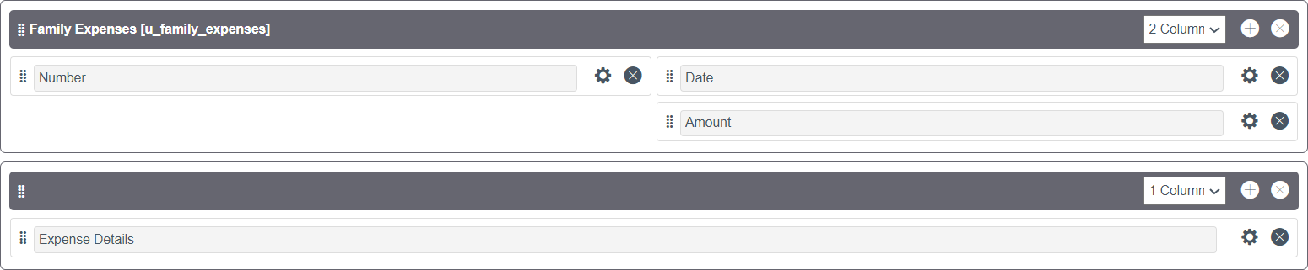

# Milestone 5: Creation of Table(Daily Expenses) Activity 1: Creation of Daily Expenses Table

1. Go to All > In the filter search for Tables > click on New.
2. Enter the Details: Label: Daily Expenses Name: Auto-Populated

Add Module to menu: Family Expenditure

1. Go to the Header and right click there>> click on Save.

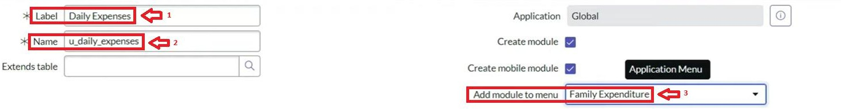

# Activity 2: Creation of Columns (Fields)

1. Near Columns Double click near insert a new row.
2. Give the details as: Column label: Number Type: String
3. Double click on insert a new row again
4. Give the details as: Column label: Date Type: Date

Double click on insert a new row again

1. Give the details as: Column label: Expense Type: Integer
2. Double click on insert a new row again
3. Give the details as:

Column label: Family Member Name Type: Reference

Max length :800

1. Double click on insert a new row again
2. Give the details as: Column label: Comments Type: String

Max length: 800

1. Go to the Header and right click there>> click on Save.

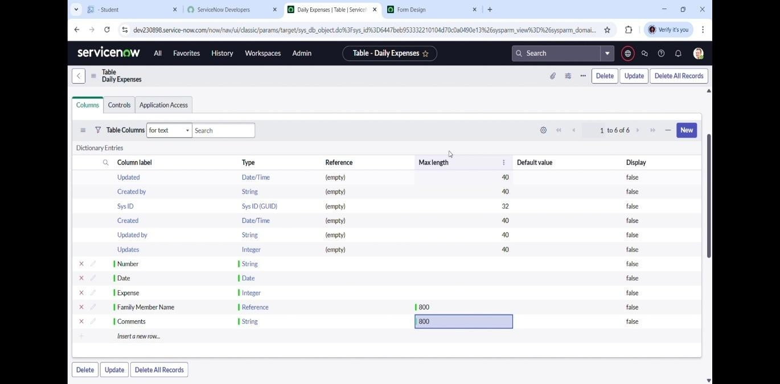

# Activity 3: Making Number Field an Auto-Number

1. Double click on the Number Field/Column.
2. Go down and double click on Advanced view In Default Value:

Use dynamic default: check the box

Dynamic default value: Get Next Padded Number

1. Click on Update.
2. Go to All >> In the filter search for Number Maintenance >> select Number Maintenance
3. Click on New.
4. Enter the below Details: Table: Family Expenses Prefix: MFE
5. Click on Submit.



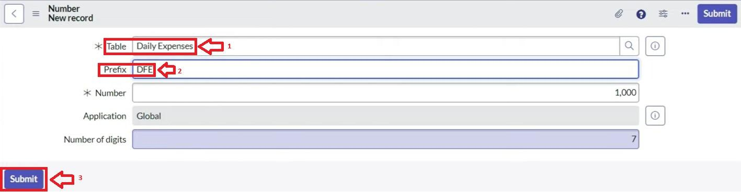

# Activity 4: Configure the Form

1. Go to All >> In the filter search for Daily Expenses >> Open Daily Expenses
2. Click on New
3. Go to the Header and right click there>> click on Configure >> Select Form Design
4. Customize or Drag Drop the form as per your requirement.
5. Make Number Read-Only Field by clicking on the gear icon and checking Read-Only
6. Make Date, Family Member Name Mandatory Field by clicking on the gear icon and checking Mandatory
7. Click on Save.

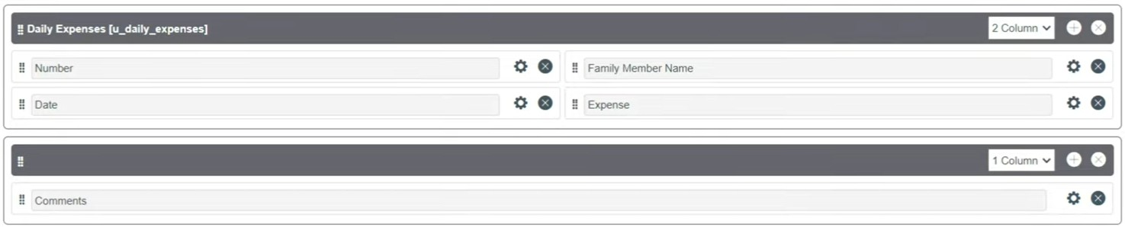

# Milestone 6: Creation of Relationship Activity 1: Creation of Relationship

1. Go to All >> In the filter search for Relationships >> Open Relationships
2. Click on New.
3. Enter the details: Name: Daily Expenses

Applies to table: Select Family Expenses Daily Expenses: Select Daily Expenses

1. Click Save.

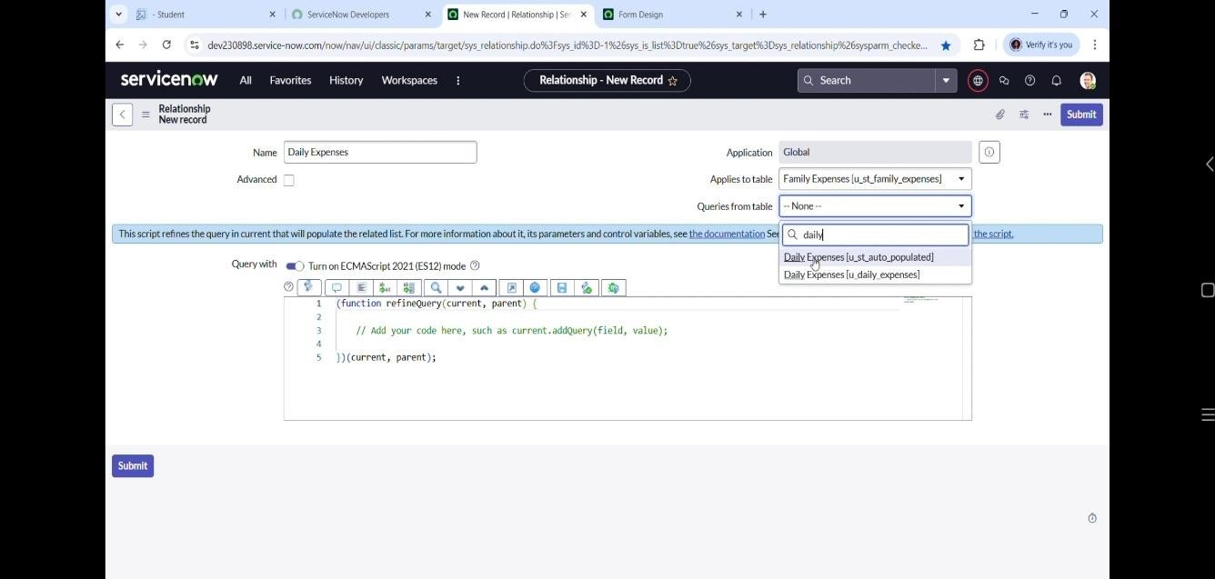

# Milestone 7: Configuring Related List on Family Expenses

**Activity 1: Configuring Related List on Family Expenses**

1. Go to All >> In the filter search for Family Expenses >> Open Family Expenses
2. Click on New
3. Go to the Header and right click there>> click on Configure >> Select Related Lists
4. Add Daily Expenses to the Selected Area.
5. Click on Save

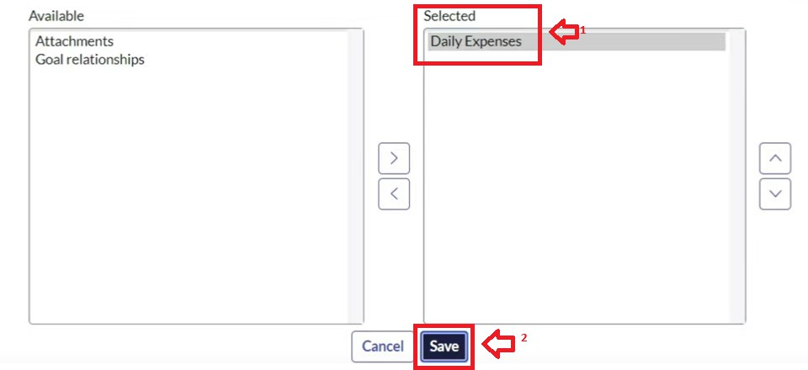

# Milestone 8: Creation of Business Rules Activity 1: Creation of Business Rules

1. Go to All >> In the filter search for Business Rules.
2. Under System Definition Select Business Rules then click on New.
3. Enter the Details:

Name: Family Expenses BR Table: Select Daily Expenses Check Advanced

1. In when to run Check Insert and Update
2. Write the below code >>
3. Go to the Header and right click there>> click on Save.

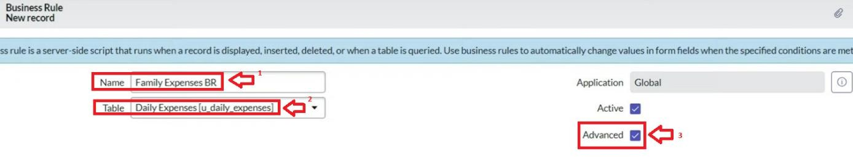

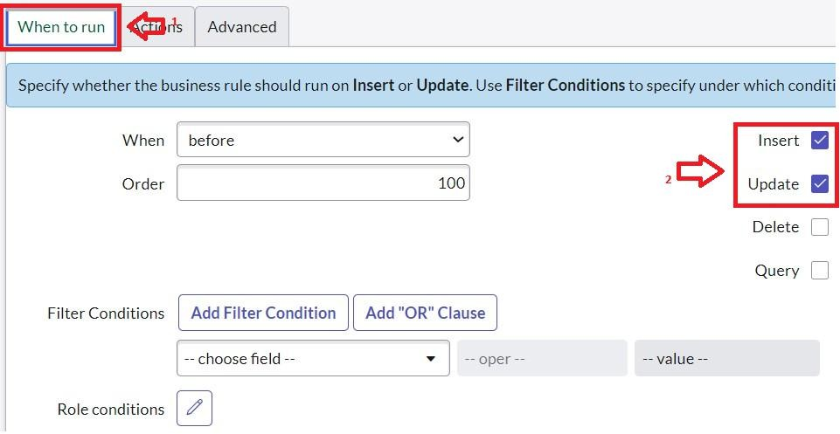

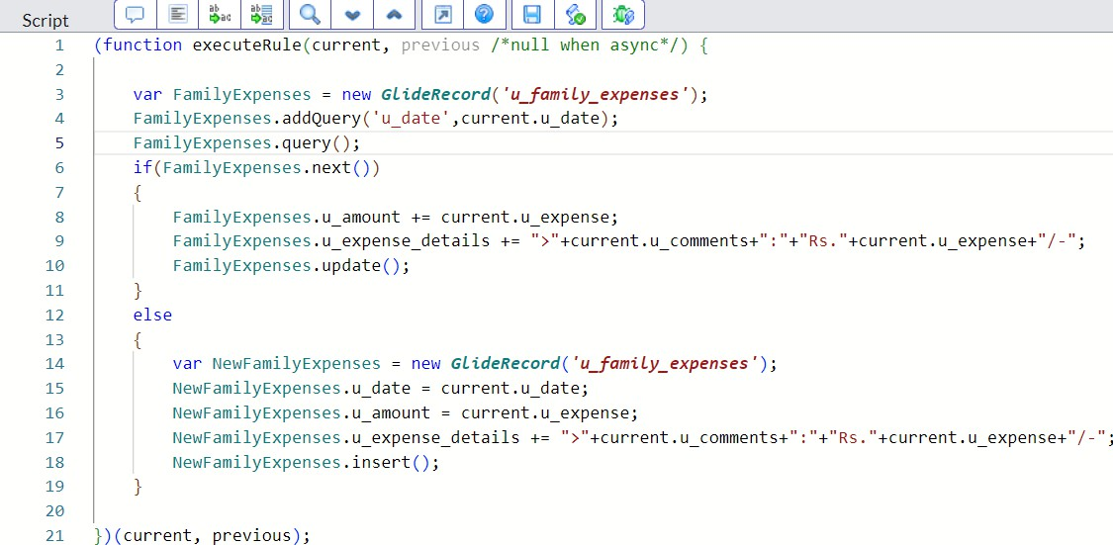

# Milestone 9: Configure the Relationship Activity 1: Configure the Relationship

1. Goto All >> In the filter search for Relationships >> Open Relationships.
2. In that, open Daily Expenses Relationship.
3. For Applies to table : Select Family Expenses.
4. In Query with : write the below Query.
5. Click on Update.

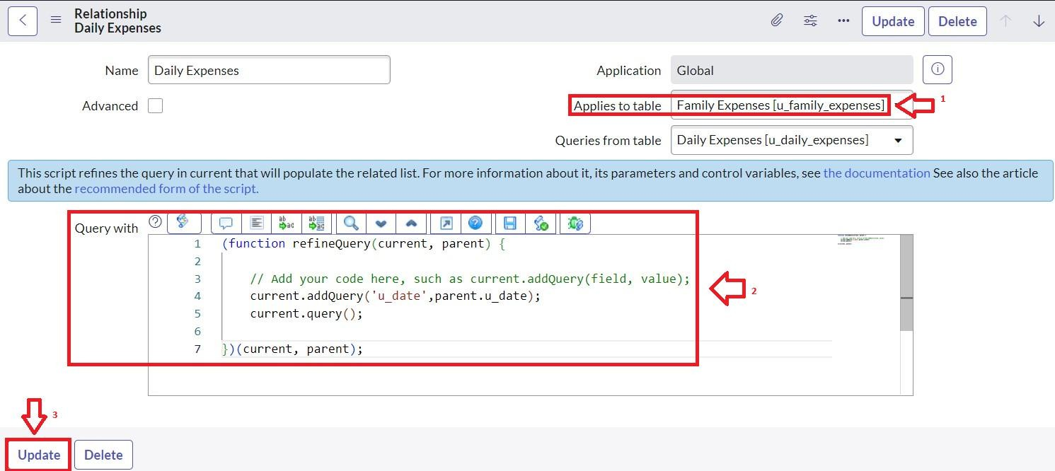

# Conclusion:

Creating and sticking to a family budget is your key to financial success. It provides clarity, helps you reach your goals, and prepares you for unexpected expenses. Family Budget means your projected income and expenditure during a predefined period. Cash flow statement measures your actual cash inflows and outflows in order to show you your net cash flow for a specific period of time.